Parth Babbar

Customer Satisfaction analysis

Aim:
The Customer Satisfaction Analysis study seeks to assess customer satisfaction levels across several industries in the United States. This study will give insights into the important elements driving customer happiness, identify trends, and facilitate data-driven decision-making to improve customer experiences. By displaying satisfaction levels, demographic breakdowns, and feedback trends, the report will assist organizations in identifying their strengths and areas for growth.
Features:
- Customer_ID: Unique identifier for each customer.
- Year: Year of the data record (ranging from 2005 to 2023).
- Customer_Satisfaction_Score: Rating on a scale of 1 to 10.
- Net_Promoter_Score: NPS score ranging from -100 to 100.
- Customer_Feedback_Volume: Number of feedback entries from a customer.
- Service_Interaction_Quality: Rating on a scale of 1 to 5.
- Response_Time_Minutes: Average response time to customer inquiries in minutes.
- Resolution_Time_Minutes: Average time to resolve customer issues in minutes.
- Repeat_Purchase_Rate: Percentage of repeat purchases.
- Customer_Loyalty_Metric: Loyalty score on a scale of 1 to 10.
- Customer_Age: Age of the customer.
- Customer_Gender: Gender of the customer (Male, Female, Other).
- Customer_Income: Annual income of the customer.
- Customer_Region: Region of the customer in the US (East, West, North, South, Midwest).
- Issue_Category: Category of the issue reported (Billing, Technical, Service).
Methodology:
- Data Cleaning:
1.Remove duplicates by validating unique identifiers such as Customer_ID.
2.Standardize forms: To guarantee consistency, standardize the forms of dates, numerical values, and category inputs.
- Handling Missing Values:
1.Identify Missing Values: Use visualisation to identify missing values in the dataset for each feature.
2.Imputation:
1.Categorical Features: For missing values, use mode imputation.
2.Numerical features: For numerical characteristics with missing data, apply median imputation.
3.Unique Identifiers: Replace missing values in 'Customer_ID' with consecutive numbers.
- Remove outliers:
1.Identify outliers: Use the IQR (Interquartile Range) approach to detect numerical outliers.
2.Handle Outliers: For each numerical characteristic, use the outlier removal function to create limits based on the IQR and remove records that fall outside of these limits.
- Final adjustments:
1.Round Numerical Columns: For readability and consistency, round numerical columns to two decimal places.
2.Save Cleaned Dataset: Save the cleaned dataset as a new CSV file to save the changes performed during data cleaning.
3.Create summary statistics and frequency tables:
1.Summary Statistics: Create descriptive statistics for numerical aspects to describe the dataset's central tendency, dispersion, and form.
2.Frequency Table: Calculate frequency counts for categorical characteristics to summarize the distribution of categories in the dataset.
Output:
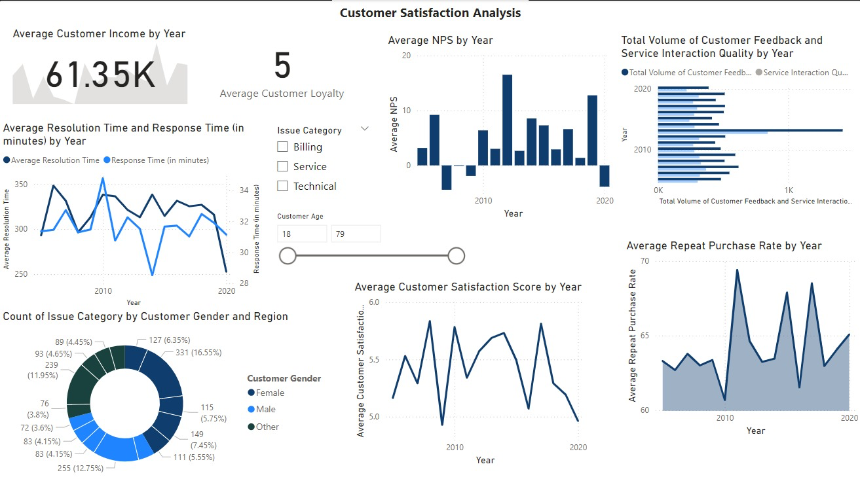
Result Analysis:
- Customer Income by Year:
The average annual income is $61.35K. This measure might reveal the financial profile of the consumer.
- Customer Loyalty:
The average score is 5. This indicates a modest amount of client loyalty, albeit the scale for this statistic is not given.
- Average Net Promoter Score by Year:
1.The Net Promoter Score (NPS) fluctuates dramatically from year to year, with some years having negative scores and others exhibiting positive trends.
2.This reflects fluctuations in consumer satisfaction and advocacy over time.
- Average Resolution and Response Time by Year:
1.From 2009 to 2020, both resolution and response times were between 250 and 350 minutes.
2.A decrease in resolution time in recent years shows that customer concerns can be resolved more quickly.
3.Response time is also trending downward, indicating faster first replies to consumer questions.
- Customer Feedback Volume and Service Interaction Quality by Year:
1.Both have increased over time, with a high in 2020.
2.A higher amount of feedback implies more customer involvement, while enhanced service interaction quality shows improvements in service delivery.
- Issue Count by Customer Gender and Region:
1.Billing concerns are the most prevalent across both genders and geographies.
2.Females and clients from region 1 have the most complaints.
- Average Customer Satisfaction Score by Year:
1.Over time, the average customer satisfaction score has fluctuated about 5.5, rising at 6 and then declining to approximately 5.
2.This implies fluctuating levels of consumer happiness, with distinct peaks and troughs reflecting times of high and low satisfaction.
- Average of Repeat Purchase Rate by Year:
1..The repeat purchase rate peaked approximately after 2010, then declined steadily.
2.This shows that client retention efforts were quite effective about 2010, but have since decreased.
Summary:
The dashboard gives a thorough picture of customer satisfaction measures across time, showing patterns and opportunities for development.
Key Insights:
- Stable Average Customer Income: The average customer income stays constant at $61.35K, demonstrating a steady financial profile across clients.
- Moderate Customer Loyalty: The average customer loyalty score of 5 indicates that there is space for development in terms of client retention and loyalty building.
- Improved Resolution and reaction Times: Resolution and reaction times have consistently reduced over the years, demonstrating more efficiency in dealing with client difficulties. This is a positive trend that reflects improved customer service operations.
- Fluctuating Net Promoter Score (NPS): The NPS varies significantly from year to year, reflecting inconsistent consumer happiness and advocacy. There are noticeable peaks and troughs, indicating different client experiences.
- Billing concerns Predominate: Billing concerns are the most prevalent complaint across genders and locations. Resolving billing issues may dramatically improve overall customer happiness.
Overall, while there are good trends in customer feedback and service quality, concentrating on inconsistencies and frequent concerns can lead to a more happy and loyal client base.

